Hospital Management System

In this project as per your instructions we have used YOLO11 CNN algorithm to detect Aadhar card number and then apply OCR algorithm to read number from detected card region. Card number region will be masked when displaying Aadhar card to doctor and then get unmask when displaying to admin.

To implement this project we have designed following modules

1. New User Sign up: new users like Doctor, Patients, Insurance companies get register with the application
2. Patient: Patient can login to system and then create profile by entering disease history, upload medical history documents, upload Aadhar card and then these details will get saved in database along with Aadhar number extracted from uploaded card. Patient can view list of available doctors and can book appointments with desired doctors and can view prescription generated by doctor. Once prescription generated then bill will also get generated
3. Insurance: insurance user can login to system and then search bill by entering patient names
4. Doctor Login: doctor can login to system and then view list of appointments for today’s date and then generate prescription. Doctor can view Aadhar card in mask format and can download and view patient medical document history.

To run project install MYSQL database and then copy content from ‘db.txt’ file and paste in MYSQL console to create database

Install python 3.10 and then install all packages given in requirements.txt file ad then double click on ‘run. Bat’ file to start python web server and get below page

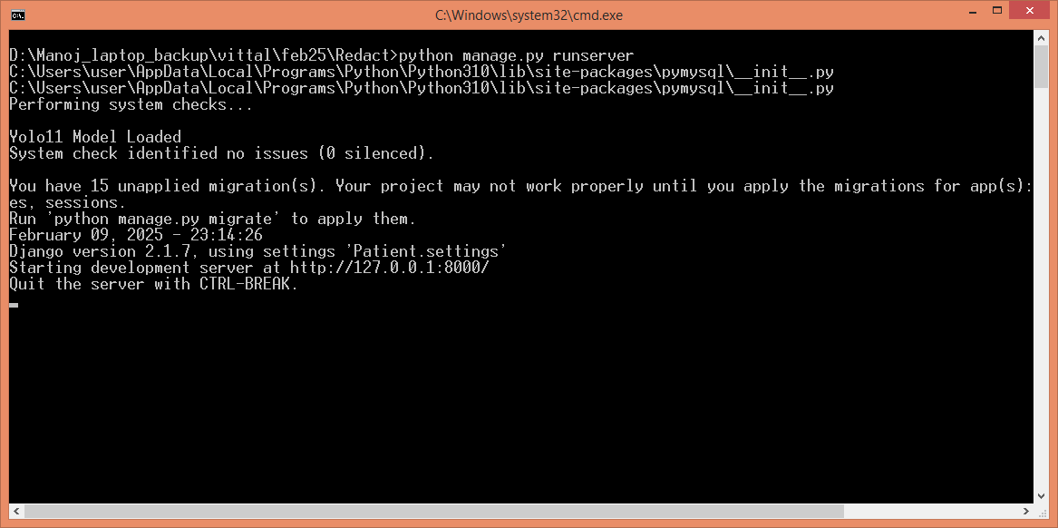

In above screen python server started and now open browser and enter URL as <http://127.0.0.1:8000/index.html> and then press enter key to get below page

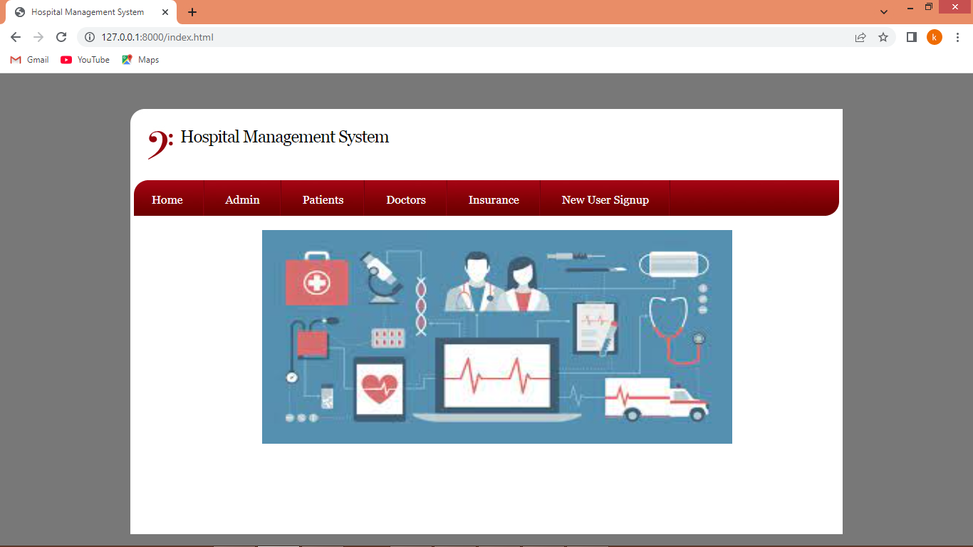

In above screen click on ‘New User Sign up’ link to get below page

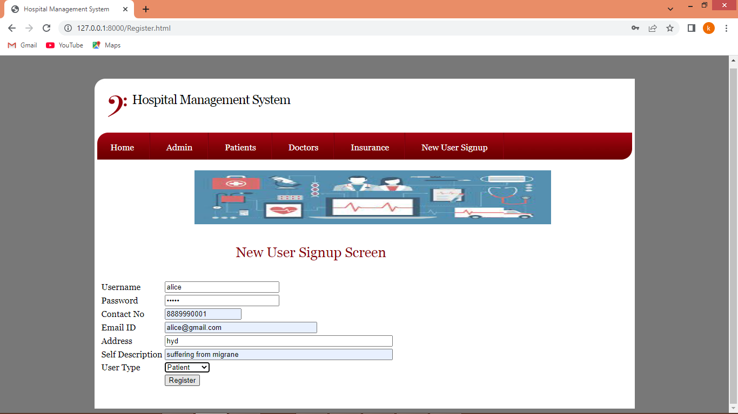

In above screen patient is entering sign up details and then press button to get below page

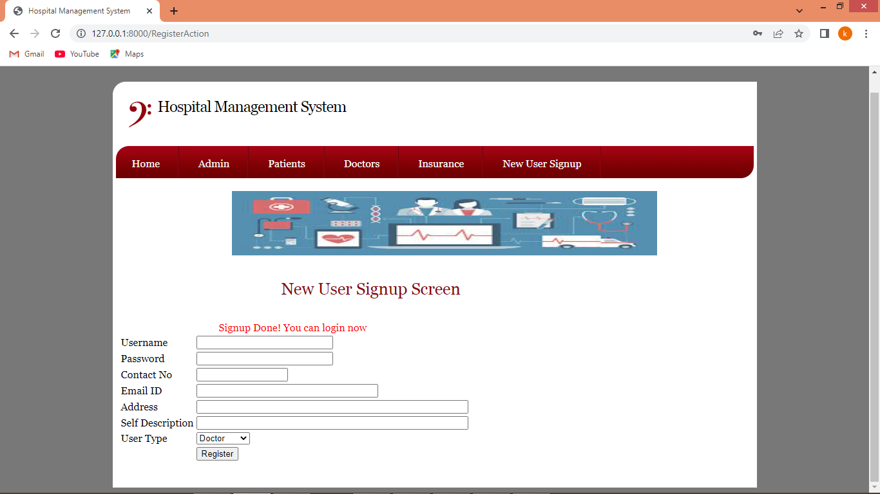

In above screen sign up process completed and similarly you can add doctors and insurance users like below page

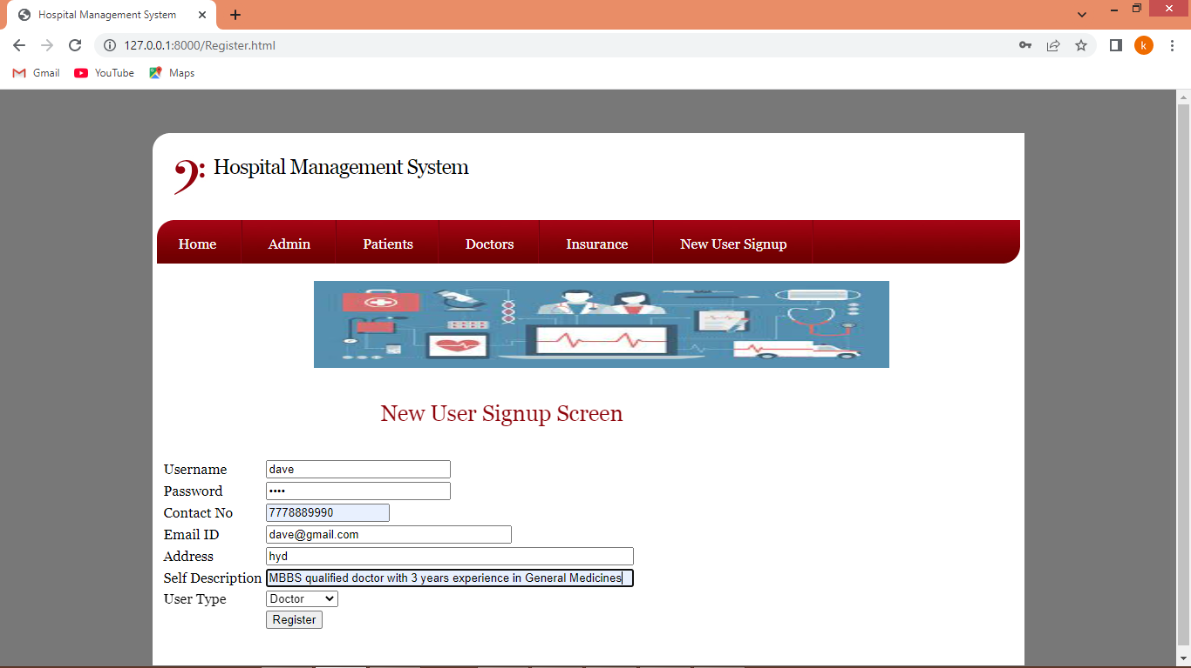

In above screen adding doctor details and then press button to complete doctor signup

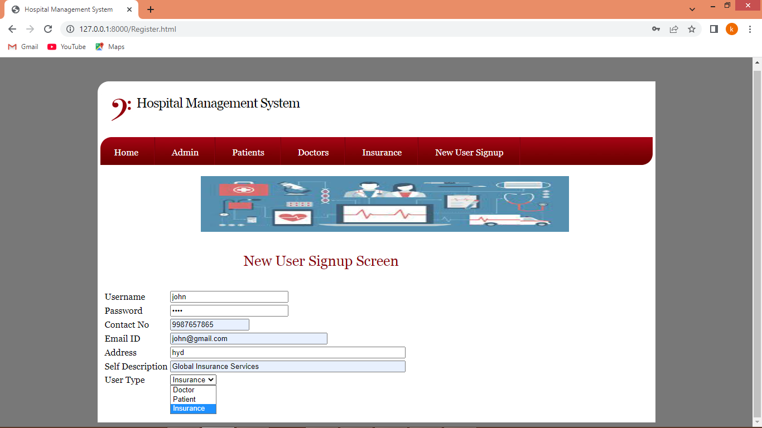

In above screen adding Insurance user and then press button to complete sign up task. Now click on ‘Patient Login’ link to get below page

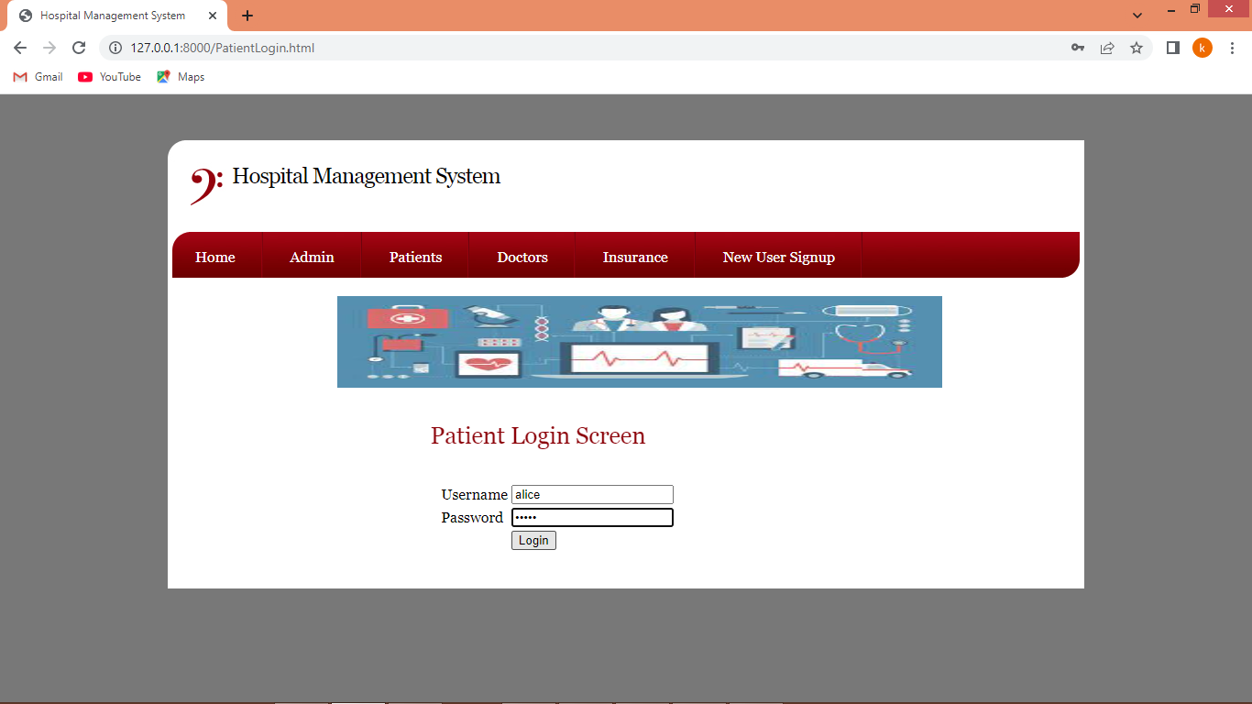

In above screen patient is login and after login will get below page

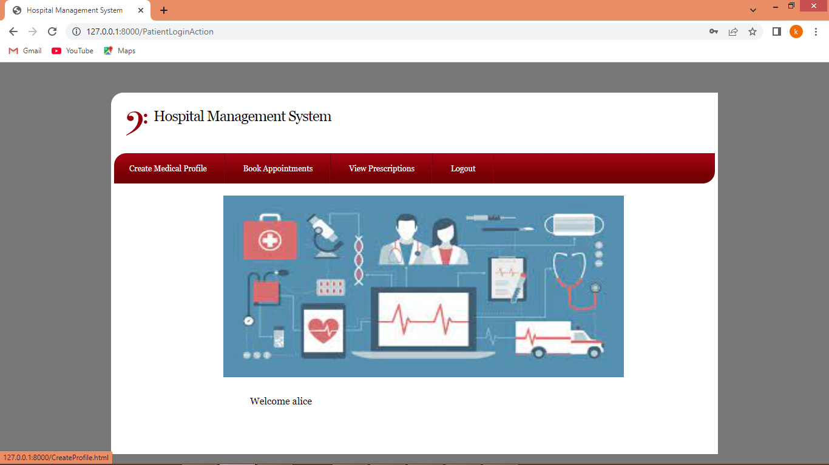

In above screen click on ‘Create Medical Profile’ link to get below page

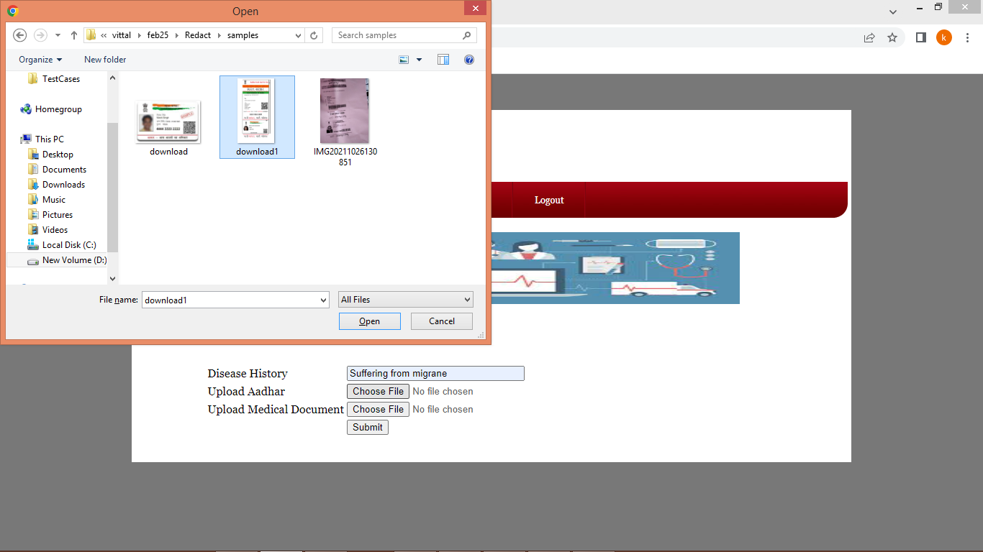

In above screen uploading sample Aadhar card and now click on ‘second button’ to upload medical history report like below page

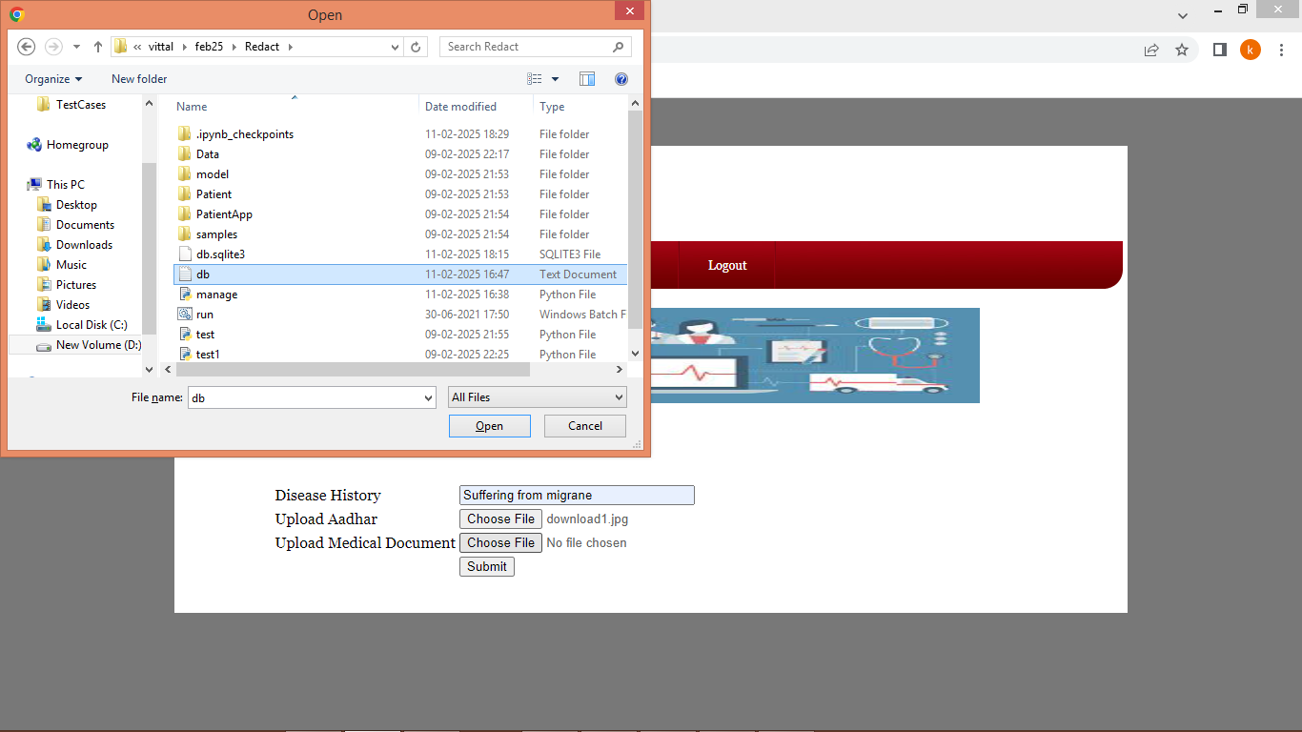

In above screen uploading medical history report and then click on ‘Open and submit’ button to load all documents and then application will extract Aadhar card number and then display below confirmation screen

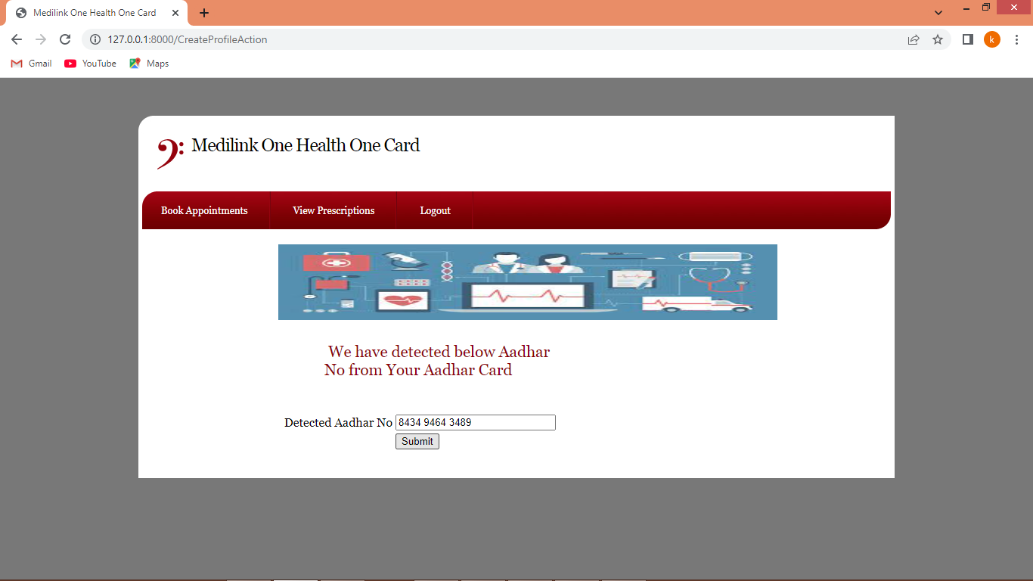

In above screen we are displaying confirmation screen to patient that extracted Aadhar correct then they can submit button or can alter to correct number and then press submit button to create profile and get below page

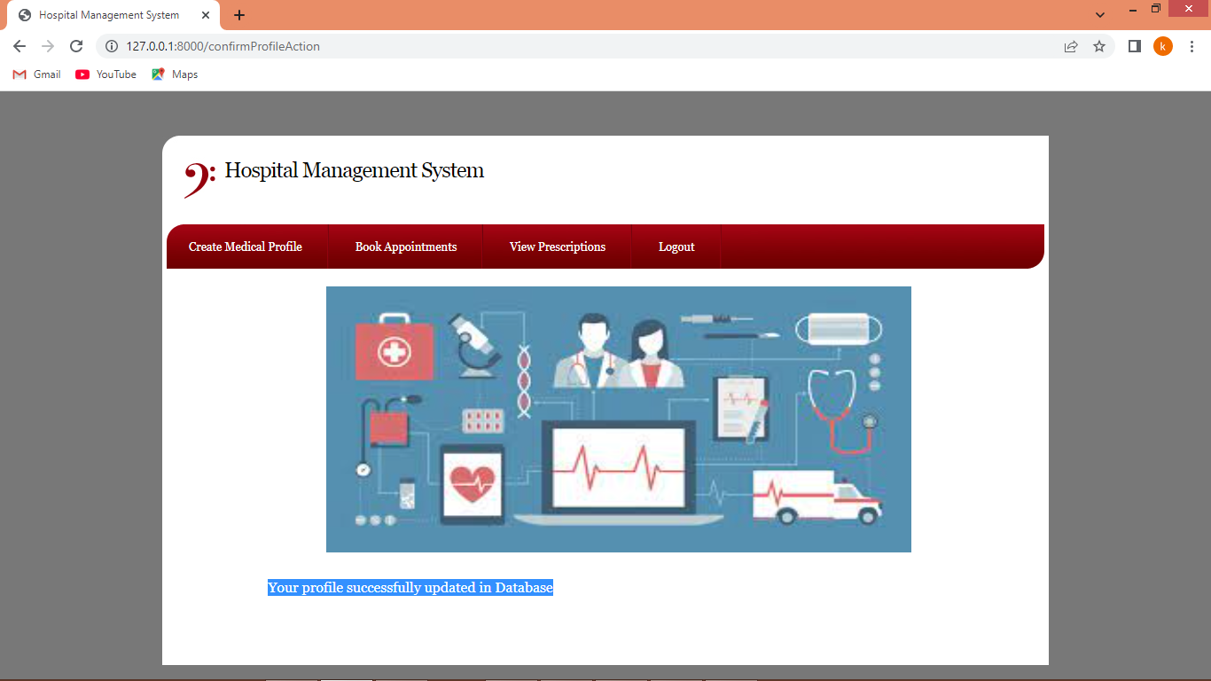

In above screen profile successfully created and now clicks on ‘Book Appointments’ link to create appointment like below page

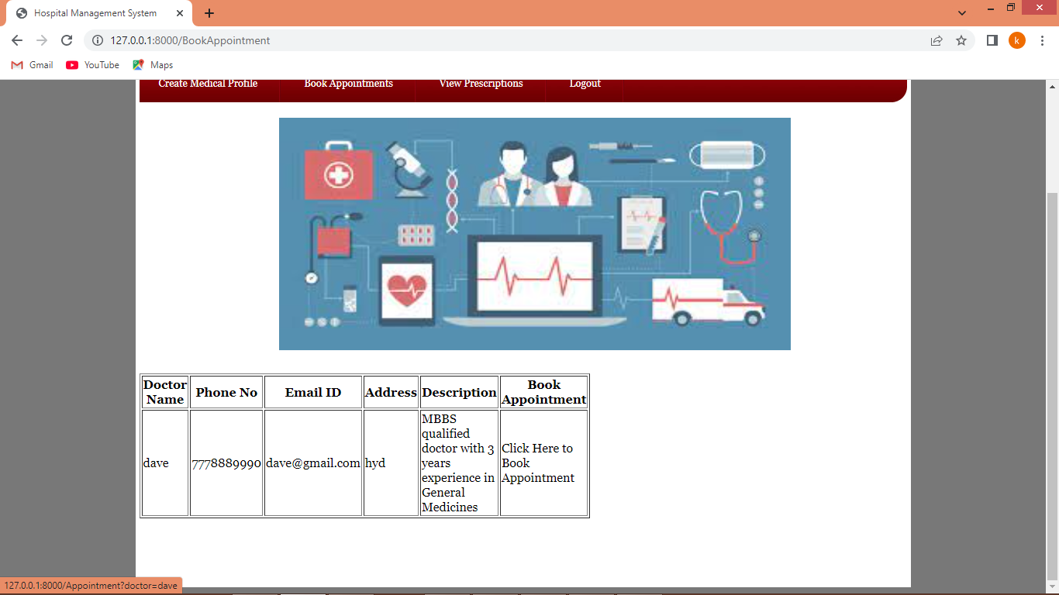

In above screen patient can view list of doctors and can click on ‘Click Here’ link to book appointment with desired doctor and get below page

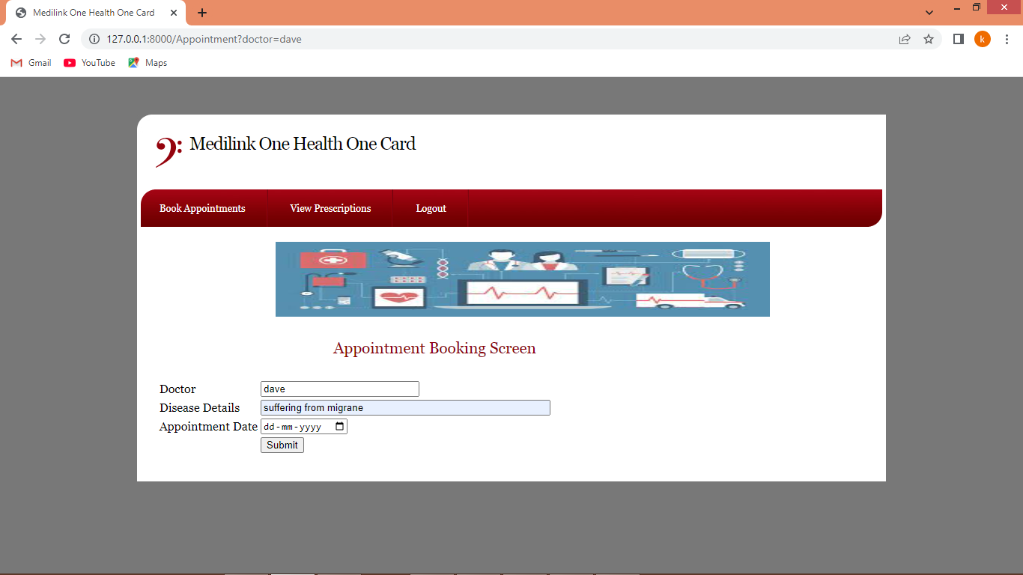

In above screen patient will enter some symptoms and then choose appointments date and then press button to complete appointment and get below page

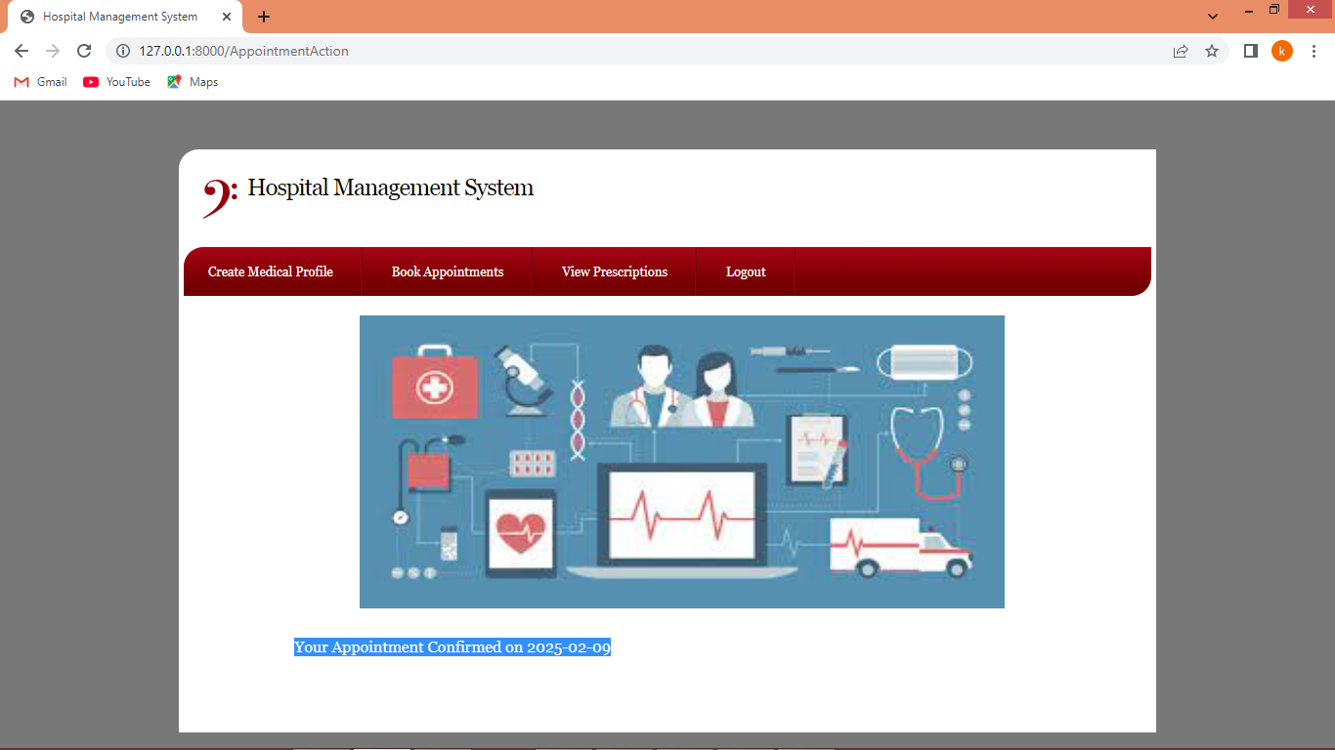

In above screen appointment is confirmed on selected date and now clicks on ‘View Prescription’ link to view generated prescription

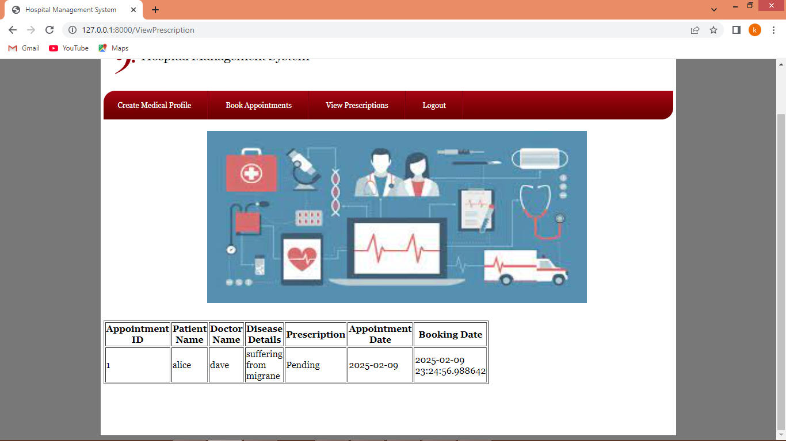

In above screen appointment is confirmed but prescription is pending as doctor not yet generated prescription. Now logout and login as doctor to generate prescription

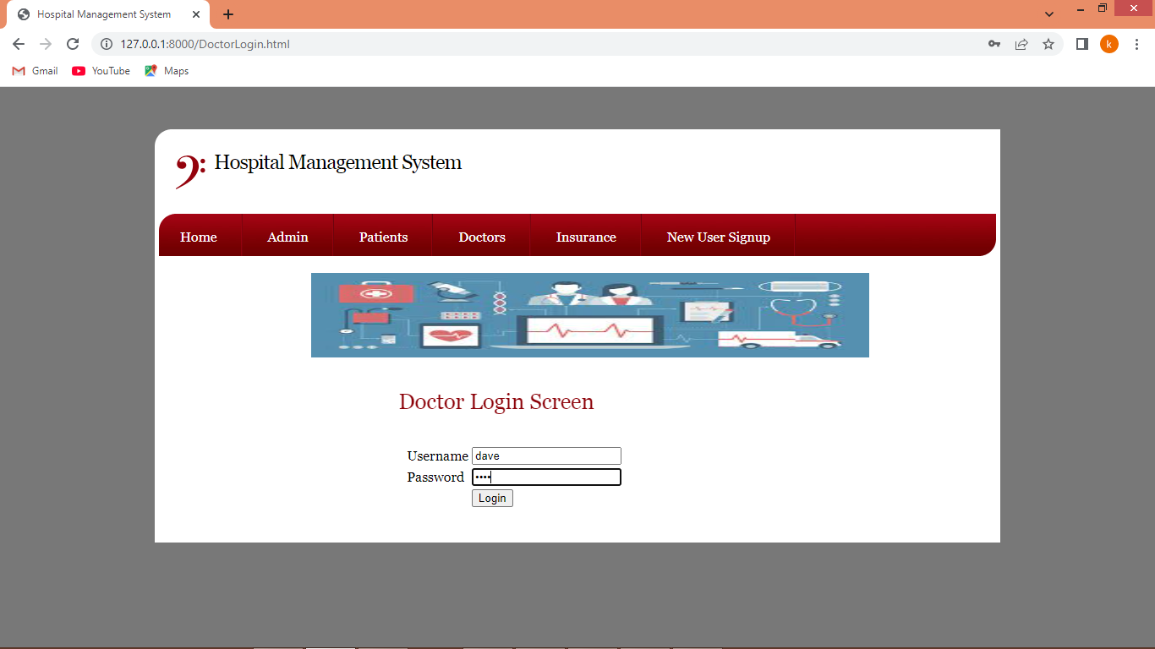

In above screen doctor is login and after login will get below page

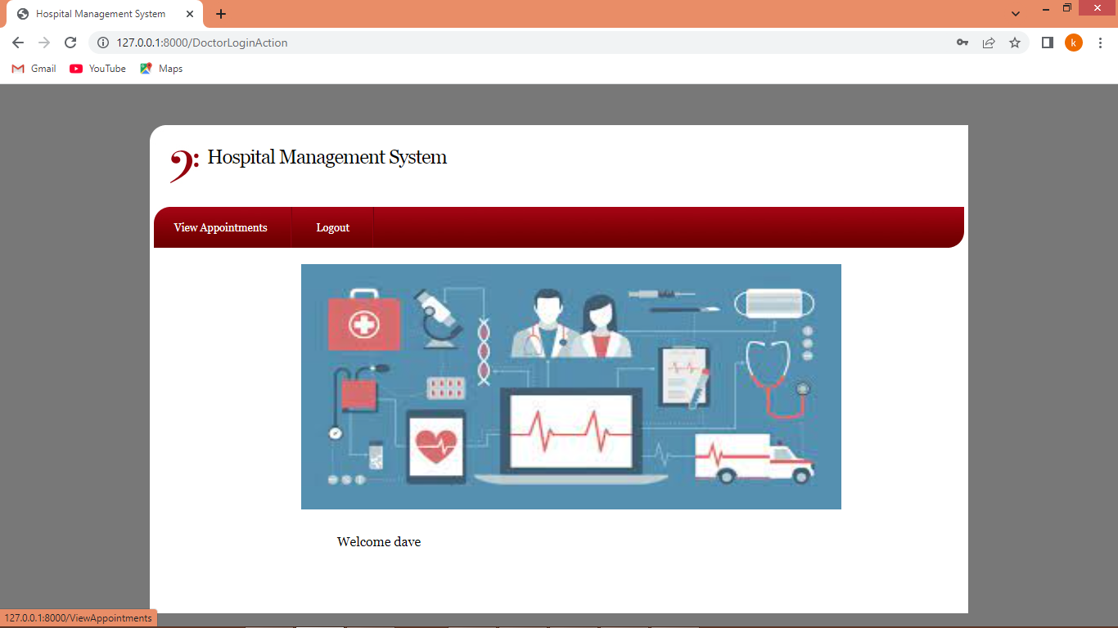

In above screen click on ‘View Appointment’ link to view all today’s appointment and get below page

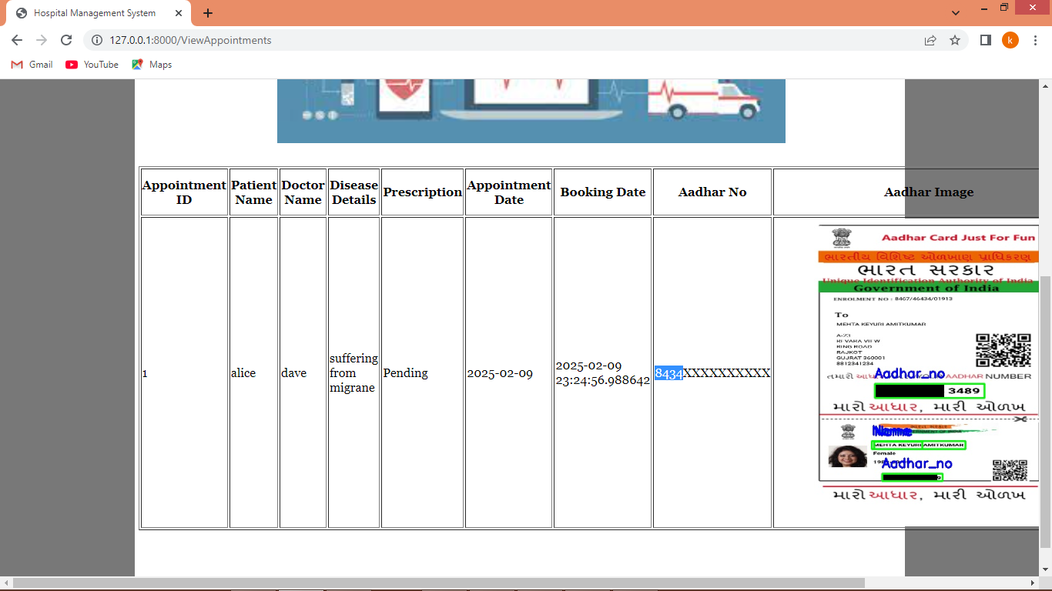

In above screen doctor can view all patient details related to appointment and can see Aadhar number on both plain text and on card is successfully masked with black colour and now in below screen you can click on ‘Generated Prescription’ link to generated prescription

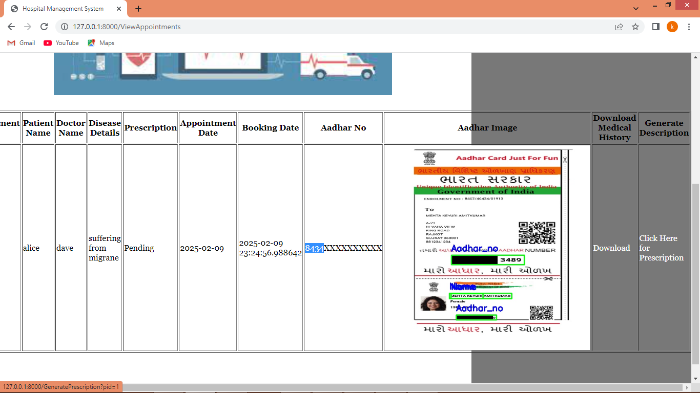

In above screen doctor can click on ‘Download’ link to download medical history document or can click on ‘Click Here for Prescription’ link to generate prescription

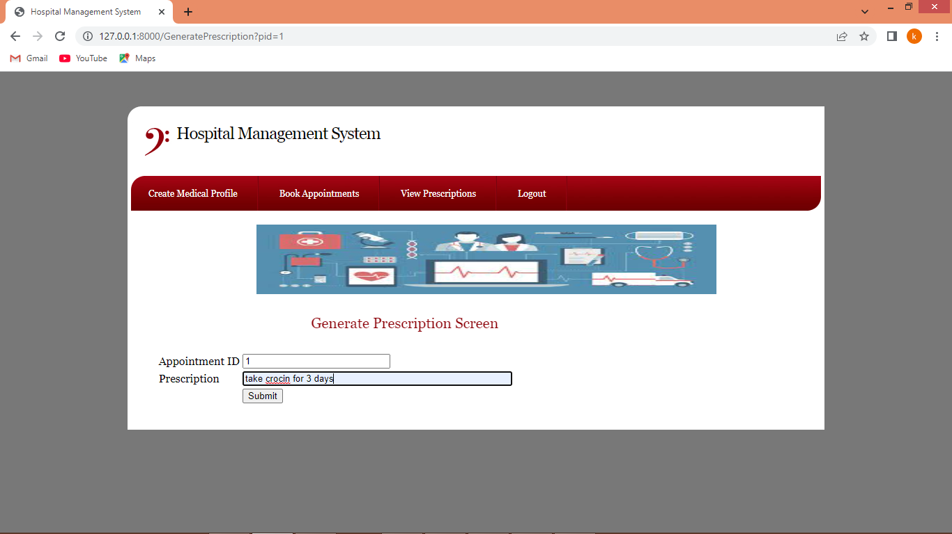

In above screen doctor will write some prescription and then press button to get below page

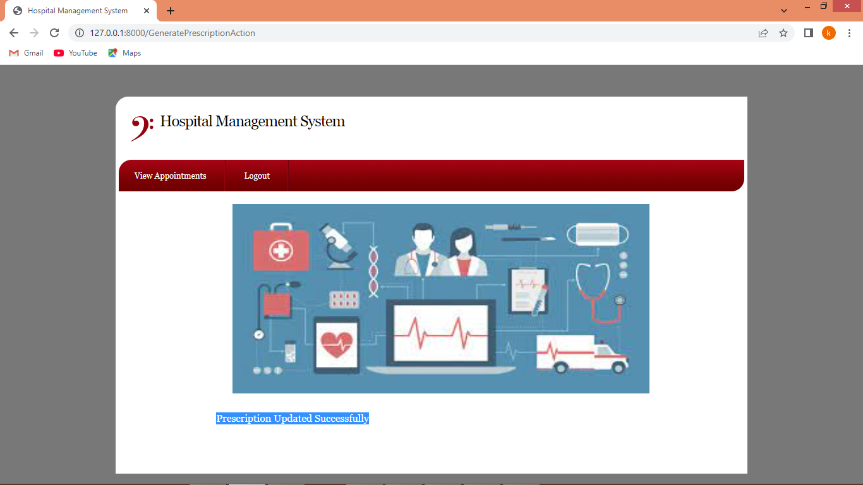

In above screen prescription successfully generated and now logout and login as ‘admin’ to view all profiles

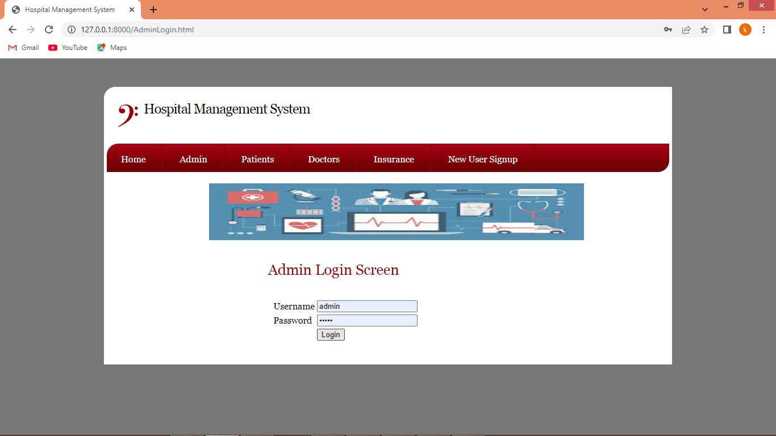

In above screen admin is login and after login admin will get below page

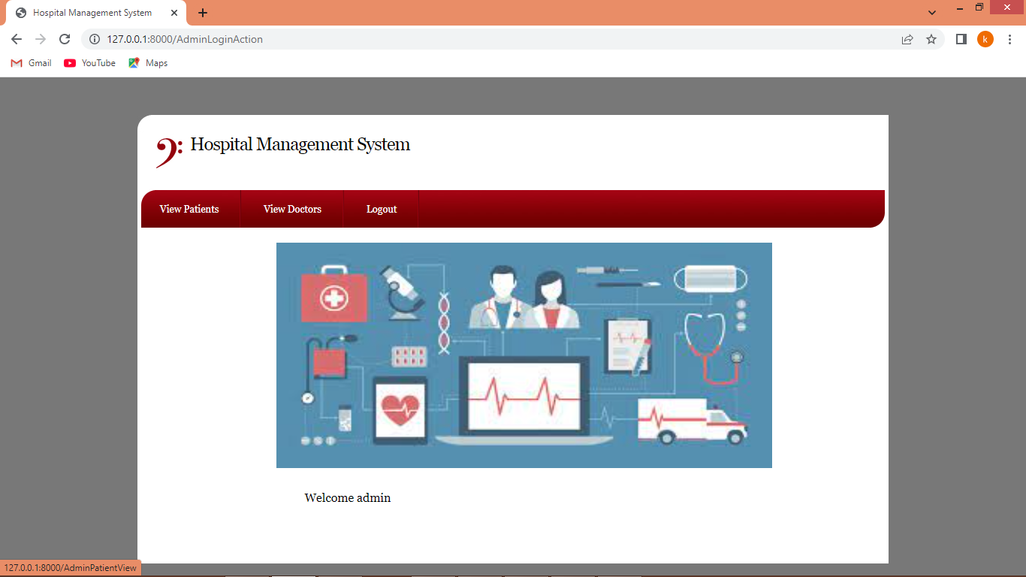

In above screen admin can click on ‘View Patients’ link to view all appointments

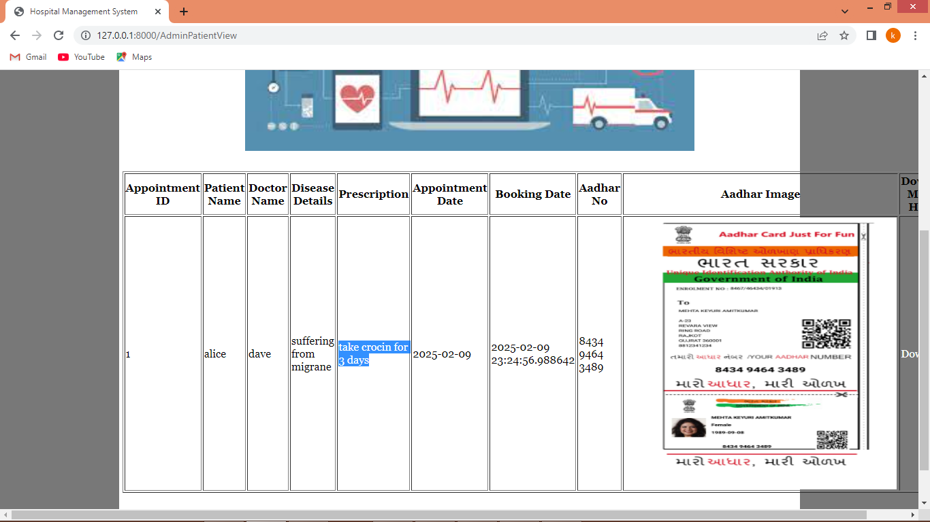

In above screen blue text admin can view ‘Prescription’ is generated and can see Aadhar card is unmasked and now click on ‘View Doctor’ link to view list of registered doctors

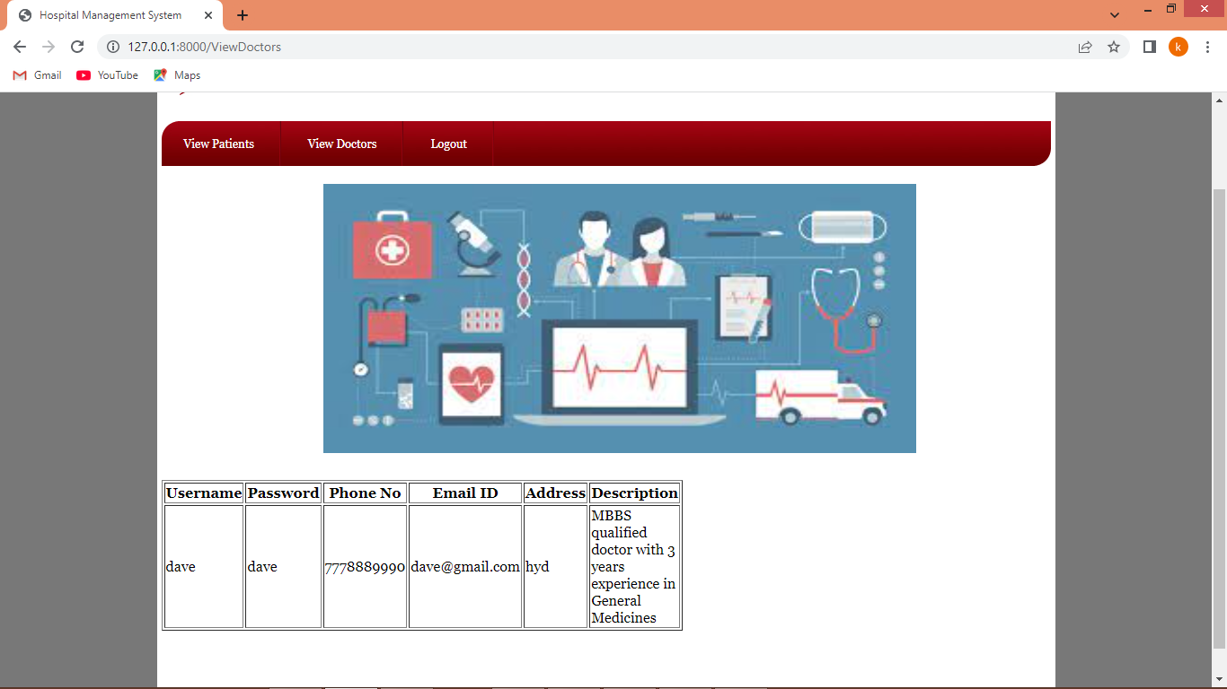

In above screen admin can view list of registered doctor list and now logout and login as insurance user

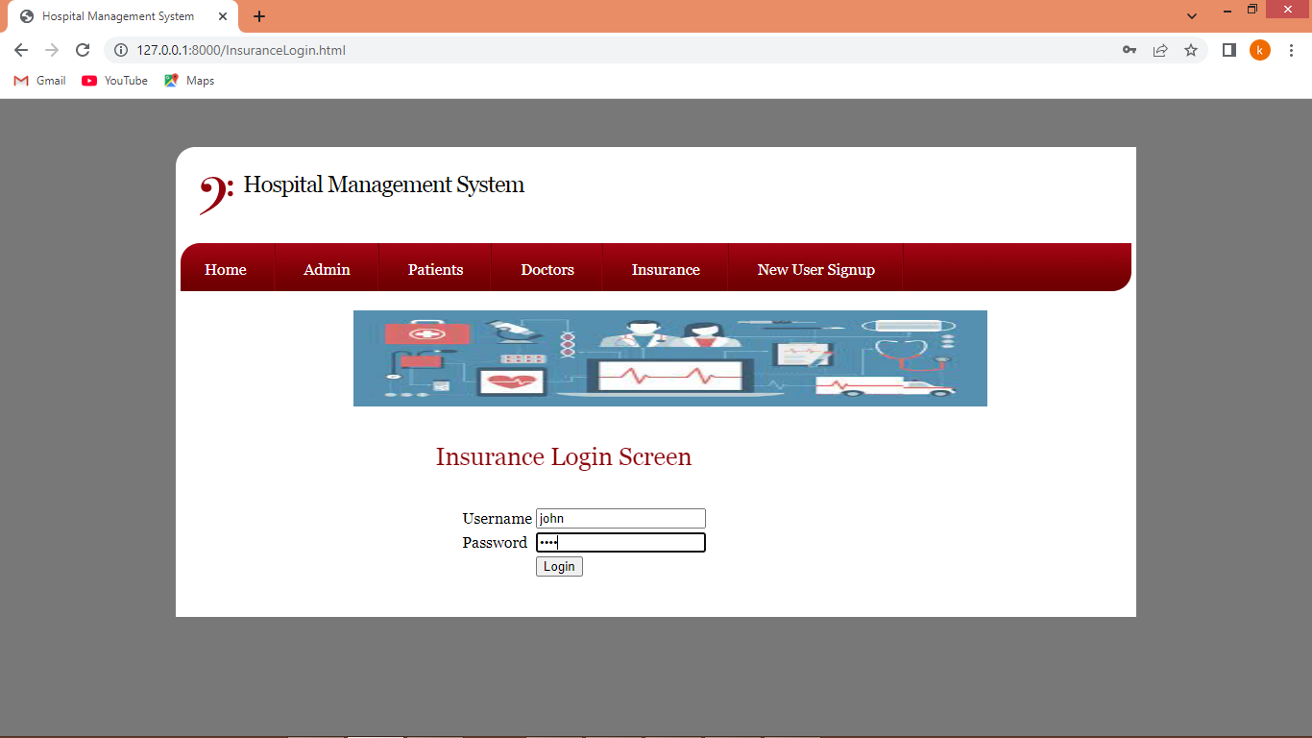

In above screen insurance user is login and after login will get below page

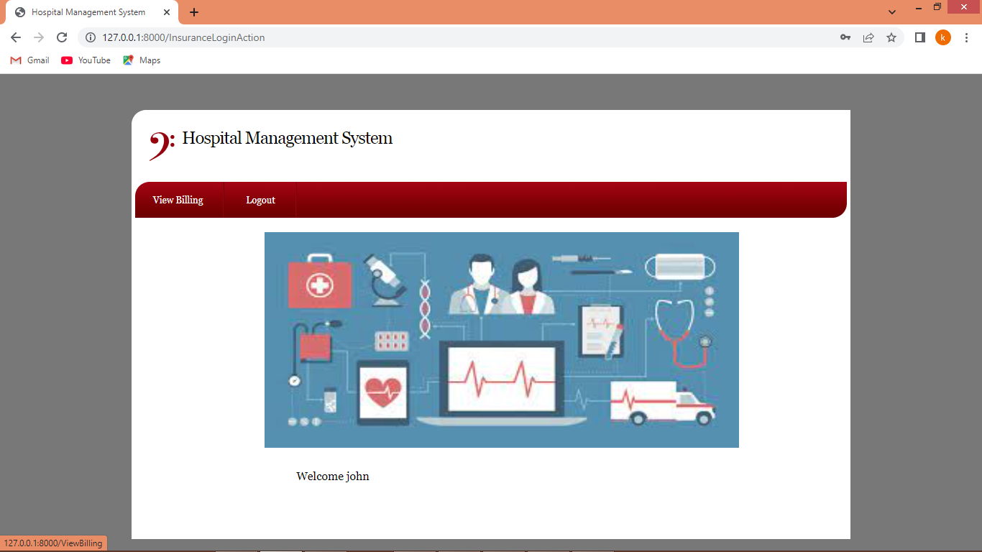

In above screen insurance user can click on ‘View Billing’ link to get below page

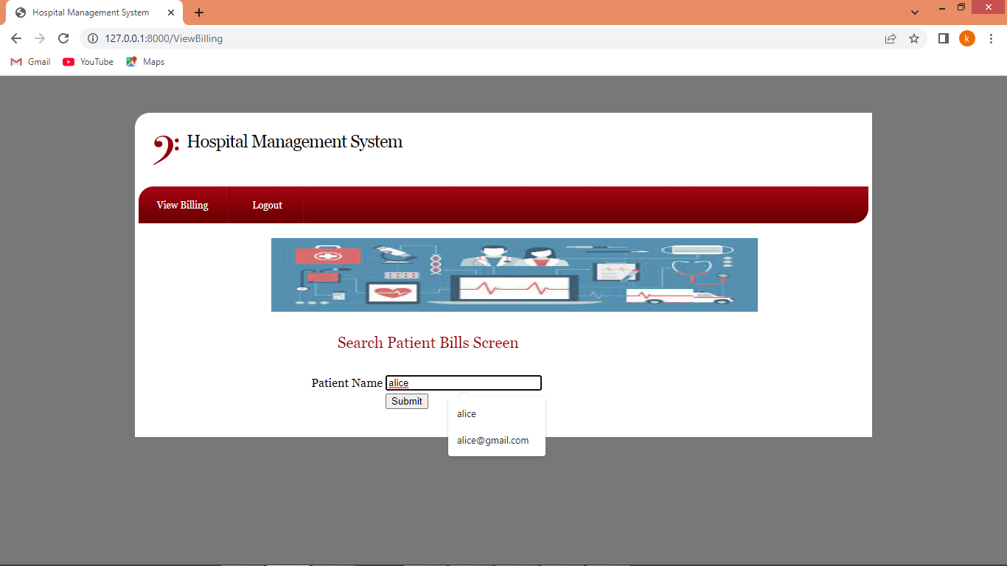

In above screen insurance user will enter patient name and then press button to get below page

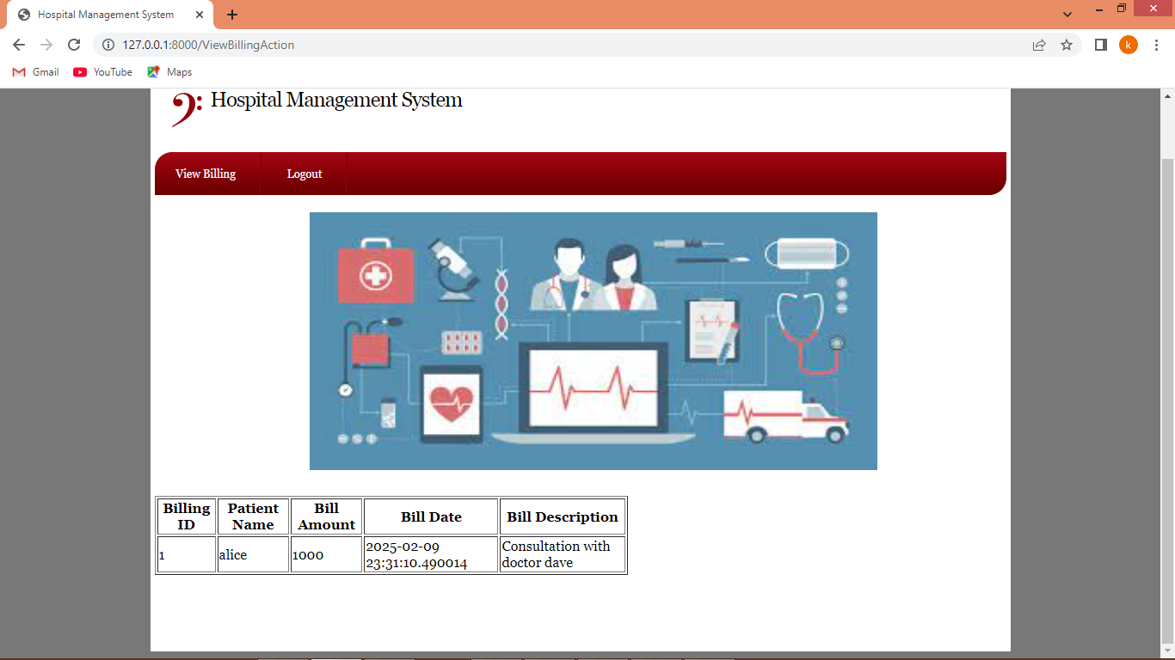

In above screen insurance user can view billing details.

Similarly by following above screens you can add as many users as you want. Below is the YOLO training performance graph

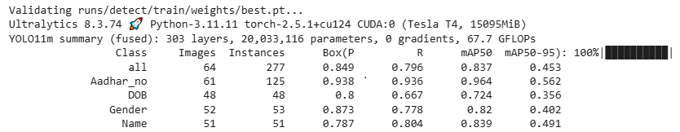

In above screen you can see precision of YOLO for each class prediction

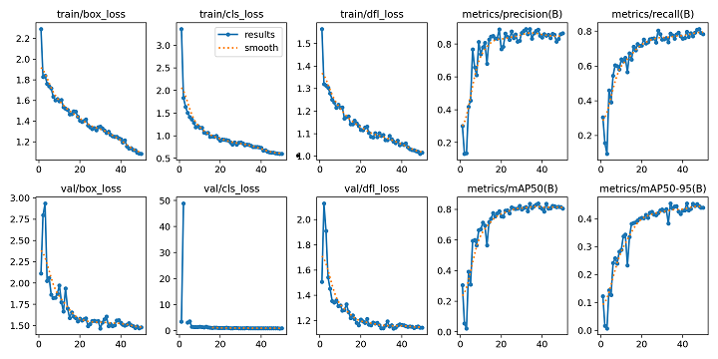

In above screen you can see YOLO training loss and precision graph where x-axis represents number of training epoch and y-axis represents loss and precision values and can see with each increasing epoch precision got increased and loss got decreased.